Homework 1
YOUR NAME HERE

Introduction
description of the problem (e.g. what are you predicting? what variables do you have available? How might this model be useful if you are successful). You should end with a sentence or two about what the impact of these models could be.

Methods
Describe your models in detail (as if explaining them to the store's CEO), as well as any pre-processing you had to do to the data.

Results
How well did your model perform on both the training and testing sets according to the various metrics, was the model overfit or underfit (how can you tell)? What do those performance metrics tell you about the model? Reflect on the role of polynomial features and interaction terms: did including them improve the model? Were they necessary? How much do you trust the results of your model (in other words, would you be confident telling the store that they should use the model? Why or why not? Are there any caveats you'd give them?) Also answer the two questions you chose from part 2 above. For each question, include your graph with a caption and provide a clear, written explanation of what the graph shows and any calculations you performed to support your conclusions.

If you want a table you can make one like this (Insert > Table):

Also: answer the two questions you chose from part 2 above. Include the image, a caption as well as your written answer.

Question 1: Why is the sky blue?
Add an image:
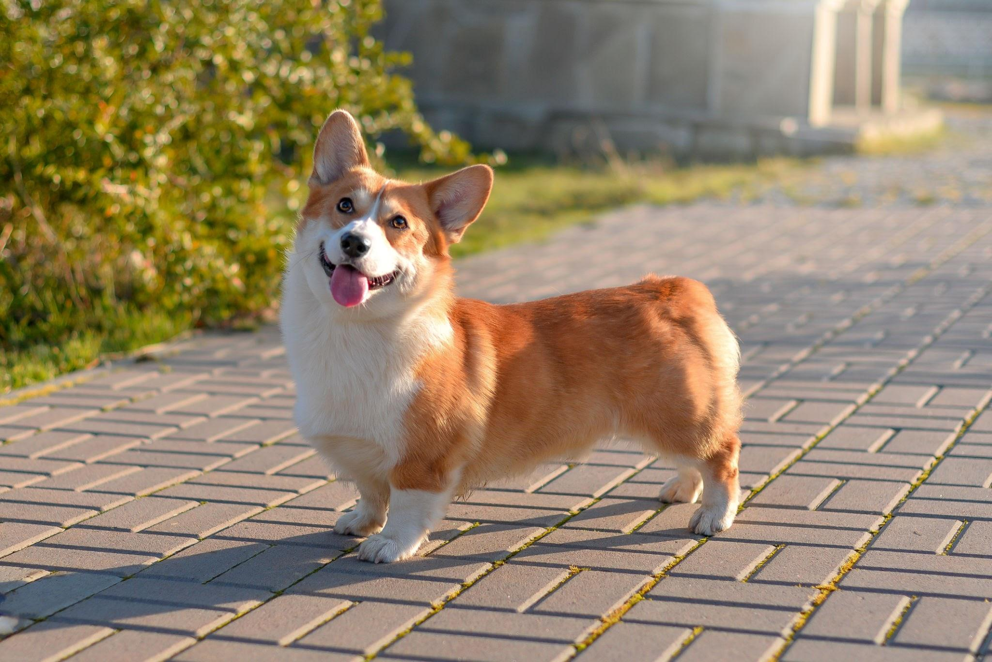
Caption 1: sdfhksjdhfksjd

My written answer goes here and I'm going to write very clearly.

Question 2: Why is grass green?

Add an image

Caption 2: sjkdfhskjdhf

My written answer goes here and I'm going to write very clearly.

Discussion/Reflection
A few sentences about what you learned from performing these analyses, and at least one suggestion for what you'd add or do differently if you were to perform this analysis again in the future.

